**09 SQL HW – Employees Database – a Mystery in two Parts**

**Part 1**

SELECT emp_no as id, emp_no, last_name, first_name, sex, hire_date

FROM employees

SELECT emp_no as id, salary

FROM salaries

1.

SELECT emp.emp_no, emp.last_name, emp.first_name, emp.sex, hire_date, sal.salary

FROM employees as emp

left JOIN salaries as sal on (emp.emp_no = sal.emp_no);

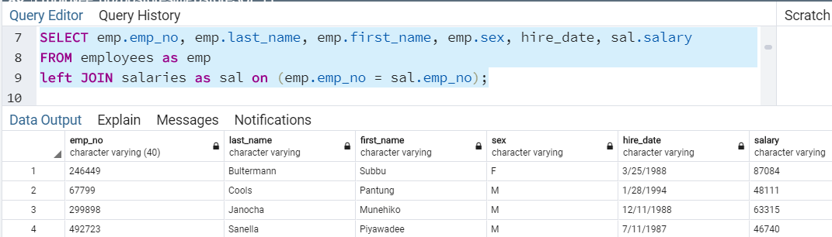

2.

SELECT emp_no, last_name, first_name, hire_date

FROM employees

WHERE hire_date BETWEEN '1986/01/01' and '1986/12/31';

3.

SELECT emp_no FROM dept_manager

SELECT * FROM departments

SELECT * FROM employees

SELECT depts.dept_no, depts.dept_name, mgr."emp_no", emps.last_name, emps.first_name

FROM departments as depts

LEFT JOIN dept_manager as mgr on mgr.dept_no = depts.dept_no

LEFT JOIN employees as emps on emps.emp_no = mgr.emp_no;

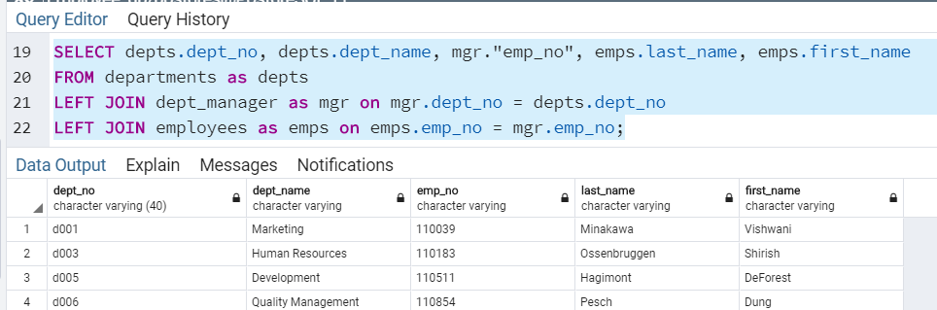

4.

SELECT emps.emp_no, emps.last_name, emps.first_name, depts.dept_name

FROM employees as emps

LEFT JOIN dept_emp as dept on emps.emp_no = dept.emp_no

LEFT JOIN departments as depts on depts.dept_no = dept.dept_no;

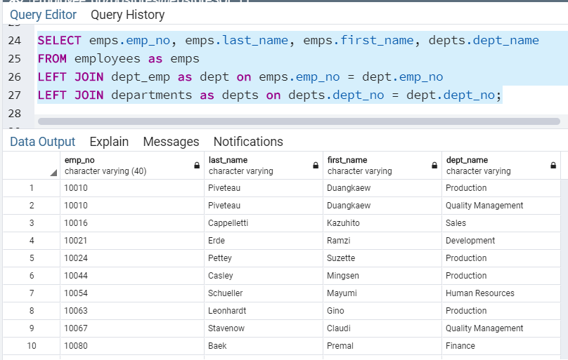

5.

SELECT emps.first_name, emps.last_name, emps.sex

FROM employees as emps

Where emps.first_name ='Hercules' and emps.last_name like 'B%';

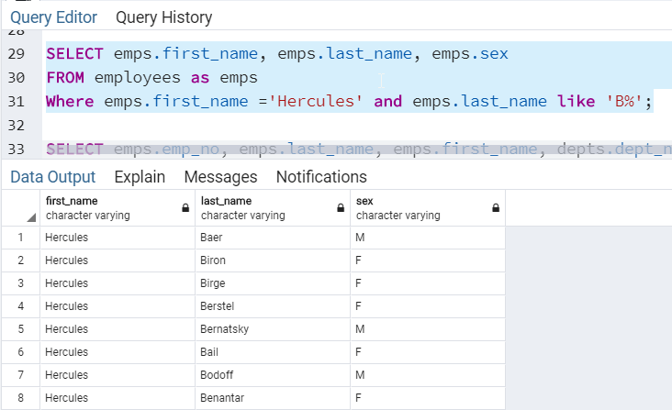

6.

SELECT emps.emp_no, emps.last_name, emps.first_name, depts.dept_name

FROM employees as emps

LEFT JOIN dept_emp as dept on emps.emp_no = dept.emp_no

LEFT JOIN departments as depts on depts.dept_no = dept.dept_no

WHERE depts.dept_name = 'Sales'

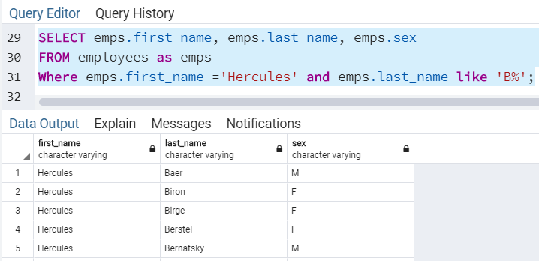

7.

SELECT emps.emp_no, emps.last_name, emps.first_name, depts.dept_name

FROM employees as emps

LEFT JOIN dept_emp as dept on emps.emp_no = dept.emp_no

LEFT JOIN departments as depts on depts.dept_no = dept.dept_no

WHERE depts.dept_name = 'Sales' or depts.dept_name = 'Development'

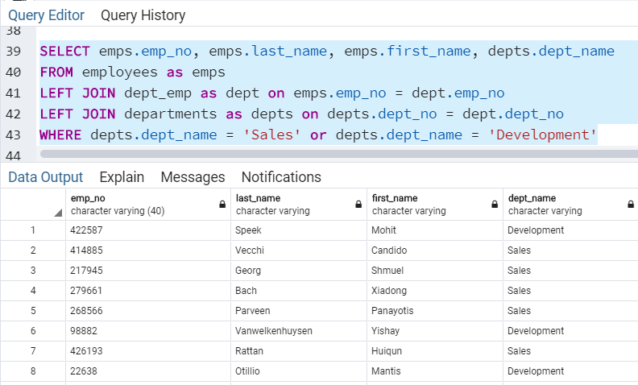

8.

SELECT COUNT(emps.last_name), emps.last_name

FROM employees as emps

GROUP BY emps.last_name

ORDER BY COUNT(emps.last_name) DESC;

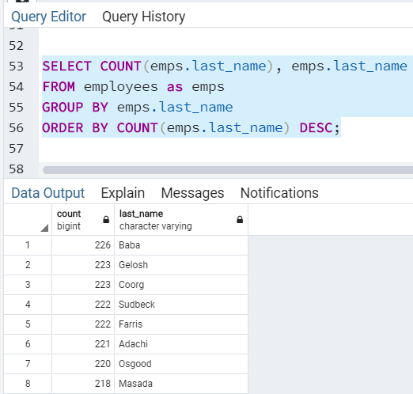

SELECT emp_no as id, emp_no, last_name, first_name, sex, hire_date

FROM employees

SELECT emp_no as id, salary

FROM salaries

SELECT emp.emp_no, emp.last_name, emp.first_name, emp.sex, hire_date, sal.salary

FROM employees as emp

left JOIN salaries as sal on (emp.emp_no = sal.emp_no);

SELECT emp_no, last_name, first_name, hire_date

FROM employees

WHERE hire_date BETWEEN '1986/01/0 and 1986/12/31';

SELECT emp_no FROM dept_manager

SELECT * FROM departments

SELECT * FROM employees

SELECT depts.dept_no, depts.dept_name, mgr."emp_no", emps.last_name, emps.first_name

FROM departments as depts

LEFT JOIN dept_manager as mgr on mgr.dept_no = depts.dept_no

LEFT JOIN employees as emps on emps.emp_no = mgr.emp_no;

SELECT emps.emp_no, emps.last_name, emps.first_name, depts.dept_name

FROM employees as emps

LEFT JOIN dept_emp as dept on emps.emp_no = dept.emp_no

LEFT JOIN departments as depts on depts.dept_no = dept.dept_no;

SELECT emps.first_name, emps.last_name, emps.sex

FROM employees as emps

Where emps.first_name ='Hercules' and emps.last_name like 'B%';

SELECT emps.emp_no, emps.last_name, emps.first_name, depts.dept_name

FROM employees as emps

LEFT JOIN dept_emp as dept on emps.emp_no = dept.emp_no

LEFT JOIN departments as depts on depts.dept_no = dept.dept_no

WHERE depts.dept_name = 'Sales'

SELECT emps.emp_no, emps.last_name, emps.first_name, depts.dept_name

FROM employees as emps

LEFT JOIN dept_emp as dept on emps.emp_no = dept.emp_no

LEFT JOIN departments as depts on depts.dept_no = dept.dept_no

WHERE depts.dept_name = 'Sales' or depts.dept_name = 'Development'

SELECT COUNT(emps.last_name), emps.last_name

FROM employees as emps

GROUP BY emps.last_name

ORDER BY COUNT(emps.last_name) DESC;